- Prove that any square matrix A is a sum of a symmetric and a skew-symmetric matrices. (Recall that a square matrix B is called symmetric if B^{T} = B and it is skew-symmetric if B^{T} = -B)

- Using row operations find the inverse of:
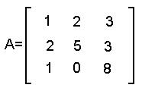

- Using row operations show that the matrix is not invertible:
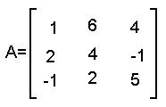

- Using row-reduction evaluate the determinant of the matrix:
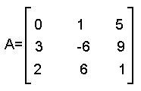

- True or False (Explain your answers)

  - If A is an invertible nxn matrix then the system is consistent for any in .
  - Any square matrix is a product of elementary matrices.
  - Each elementary matrix is invertible and its inverse is an elementary matrix.
  - A sum of two elementary matrices is always an elementary matrix.
  - If B is obtained from A by multiplying one of the rows of A by 5 then det(B) = 5det(A)
  - If 3 times the first row of A was added to the second row of A to obtain a new matrix B then det(B) = 3det(A)

